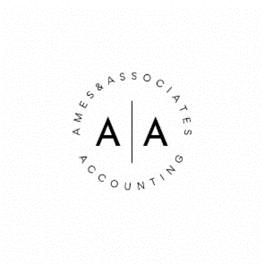
RECORD RETENTION GUIDE FOR INDIVIDUALS:
How long to keep records is a combination of judgment and state and federal statutes of limitations, as federal tax returns can be audited for up to three years after filing and up to six years if the IRS suspects underreported income, it’s wise to keep tax records at least seven years after a return is filed.

Requirements for records kept electronically are the same as for paper records.

RECORDS:
Tax returns | 7 Years
Tax return - COMPLEX | Permanent
W-2 | 7 Years
Supporting tax deduction record | 7 Years
Bank deposits/statements | 7 Years
Charitable contribution record | 7 Years
Credit card record | 7 Years
Tax return log | 7 Years
Stock purchase and sale Ownership | +7 Years
Dividend reinvestment Ownership | +7 Years
Year-end brokerage statement Ownership | +7 Years
Investment property purchase Ownership | +7 Years
Home Purchase documents Ownership | +7 Years
Home improvement documents Ownership | +7 Years
Retirement plan records | Permanent
IRA records (Form 8606) | Permanent
Insurance policy Life | + 3 Years
Loans Life | + 3 Years
Wills & Trusts | Permanent
Business License | Permanent

