RECORD RETENTION GUIDE FOR SELF-EMPLOYED & SMALL BUSINESS:

[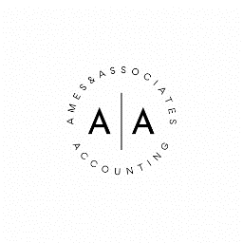](https://amesandassociates.com)In business, good recordkeeping is essential not only for tax reporting purposes but also for the success of the company. The guidelines below give retention periods for the most common business records. Call us if you’d like more information or assistance with your record retention program.

**ACCOUNTING RECORDS:**

|  |  |
| --- | --- |
| Accounts receivable/payable | 7 Years |
| Audit reports | Permanent |
| Chart of accounts | Permanent |
| Depreciation schedules | Permanent |
| Fixed asset purchases | Permanent |
| General Ledger | Permanent |
| Inventory records | 7 Years |
| Loan payment schedules | 7 Years |
| Purchase orders | 7 Years |
| Sales records | 7 Years |
| Tax returns | Permanent |
| Bank statement | 7 Years |
| Cancelled check/Electronic Payment Records | 7 Years |

**EMPLOYEE RECORDS:**

|  |  |
| --- | --- |
| Benefit plan | 7 Years |
| Employee record | 7 Years |
| Payroll records | 7 Years |
| Pension plan | Permanent |

**PROPERTY RECORDS:**

|  |  |
| --- | --- |
| Construction records | Permanent |
| Leasehold improvements | Permanent |
| Lease payment Term | + 4 Years |
| Real property purchase | Permanent |

**CORPORATE RECORDS:**

|  |  |
| --- | --- |
| Board Minutes | Permanent |
| Bylaws | Permanent |
| Business License | Permanent |
| Major contracts | Permanent |
| Minor contracts | Life |
| Insurance policies | Life |
| Lease/mortgage | Permanent |
| Patents/Trademarks | Permanent |
| Shareholder records | Permanent |
| Stock records | Permanent |
| Stock ownership records | Permanent |